Background for Pointing Control
Euler Angles
- Rigid body described by three positional coordinates, and three angular coordinates
- $x, y, z$
- $θ, ϕ, ψ$
- First rotation is $ϕ$ about the $z$ axis
- Second rotation is $θ$ about the $x$ axis
- Third rotation is $ψ$ about the $y$ axis
- Corresponds to ideas of pitch, roll and yaw
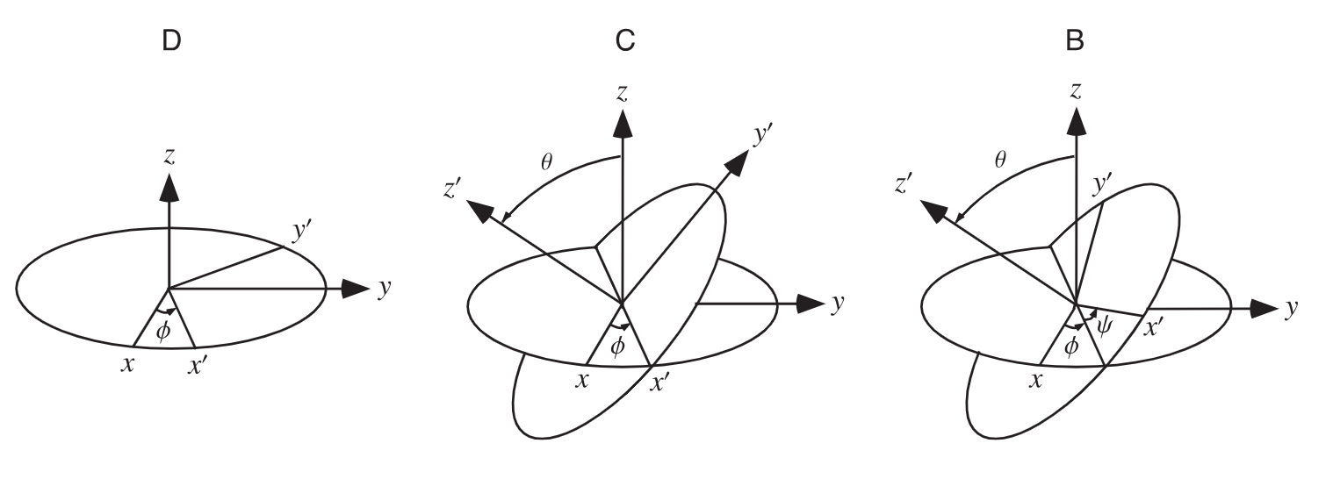
https://mathworld.wolfram.com/EulerAngles.html
Quaternions
- Is a 4-D tuple
- Addition is component wise
- Multiplication is not commutative
- $\left(a,b,c,d\right)∙\left(w,x,y,z\right)=(aw-bx-cy-dz,ax+bw+cz-dy,$$$ay-bz+cw+dx,az+by-cx+dw)$$
- $p∙\left(q∙r\right)=\left(p∙q\right)∙r$
- $i^{2}=j^{2}=k^{2}=-1$
- $ij=-ji=k$
- $jk=-kj=i$
- $ki=-ik=j$
- Scalar multiplication
- $k\left(a,b,c,d\right)=(ka,kb,kc,kd)$
- Four specific quaternions
- $I =(1,0,0,0)$
- $i=(0,1,0,0)$
- $j=(0,0,1,0)$
- $k=(0,0,0,1)$
- $\left(a,b,c,d\right)=aI+bi+cj+dk$

- Consider $(w,q_{1},q_{2},q_{3})$
- Quaternion norm
- $\left|q\right|=\sqrt{w^{2}+q_{1}^{2}+q_{2}^{2}+q_{3}^{2}}$
- Pure quaternion
- $q=(0,q_{1},q_{2},q_{3})$
- Identity quaternion
- $q=(1,0,0,0)$
- Conjugate quaternion
- $\overline{q}=(w,-q_{1},-q_{2},-q_{3})$
- Quaternion Inverse
- $q^{-1}=\frac{\overline{q}}{q^{2}}$
- Unit Quaternion
- $\left|q\right|=1$

Spacecraft Moment of Inertia
- Spacecraft is a small CubeSat with no large deployable surfaces (i.e., large solar panels), hence its inertia tensor is predictable and will remain constant during manoeuvres (I.e., none of the structures will flex much)
- Additionally, magnetorquers produce relatively low torque, hence there will be minimal forces acting on the spacecraft, hence little flex in its structures

PIDs
- It is a type of controller where it compares the current value (process variable) to the target value (set point), and based on the error between the two values in executes a change
- The deadtime (time between the angle changing and the change being measured by the system) is very low
- Creates the response based on three values
- The proportional response
- Depends purely on the error between the set point and the process variable
- This alone can cause errors when the error is large, causing too large responses, causing the system to lose control
- The integral response
- This response sums the error terms up over time, meaning it continually increases until the error term is zero, driving the system towards a steady state
- The steady state error is the final difference between the set point and process variable
- An issue can occur called integral windup where the integral action saturates the controller without driving the controller towards an error of zero
- This phenomenon occurs when the integral term accumulates excess error leading to overshoot, oscillations and instability. This occurs when the controller output saturates, meaning it reached its maximum or minimum limit, and the integral term continues to integrate the error, despite the actuator not being able to respond further
- The derivative response
- The derivative decreases the output if the process variable is rapidly increasing
- It is proportional to the rate of change of the process variable
- Increasing the derivative time parameter $T_{d}$ cause the control system to react more strongly
- Most practical systems use small $T_{d}$ as the derivative response is very sensitive to noise in the process variable signal
- If the sensor feedback signal is too noisy or control loop rate too slow, the derivative response can make the system unstable
- The loop cycle time is the interval of time between calls to the control system
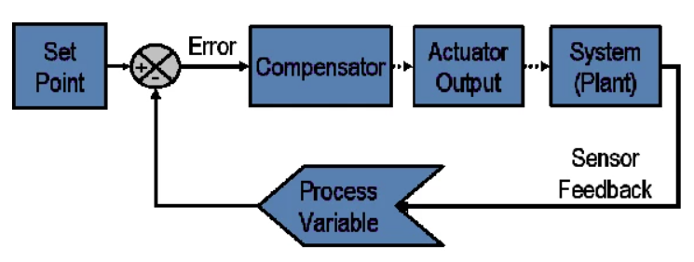
https://www.youtube.com/watch?v=tFVAaUcOm4I
https://www.ni.com/en/shop/labview/pid-theory-explained.html?srsltid=AfmBOorrSZV8IAi3QxpNadOuWj0BuVQOH2qtOi9I7PKuWoErszNxRdpA

Lyapunov Stability
- General idea is to have a function that is always decreasing to a certain value
- Consider function $\dot{x}=f(x,t)$
- $x\left(t_{0}\right)=x_{0}$
- $x∈R^{n}$
- $f(x,t)$ is Lipschitz continuous with respect to $x$, uniformly in $t$ and piecewise continuous in $t$
- A point $x^{*}$ is considered an equilibrium point if $f\left(x^{*},t\right)=0$
- An equilibrium point is stable in the sense of Lyapunov at equilibrium point $x^{*}=0$ at $t=t_{0}$ if
- For any $ϵ>0 ∃ δ\left(t_{0},ϵ\right)>0$ such that
- $\left|\left|x\left(t_{0}\right)\right|\right|<δ\underset{⇒}{ }\left|\left|x\left(t\right)\right|\right|<ϵ, ∀t≥t_{0}…(1)$
- Effectively saying that for any equilibrium point $x$ at $t_{0}$ where $x$ is within $δ$ of the origin, $x$ will remain within $ϵ$for all time
- I.e., all points that start near an equilibrium point remain there for all time
- Stability is defined at the time instant $t_{0}$. Uniform stability says that $δ$ is not a function of $t_{0}$, meaning the stability is true for all $t$
- An equilibrium point $x^{*}=0$is asymptotically stable at $t=t_{0}$ if
- $x^{*}$ is stable and
- $x^{*}$ is locally attractive, i.e., $∃ δ(t_{0})$
- $\left|\left|x\left(t_{0}\right)\right|\right|<δ\underset{⇒}{ }\lim_{t→∞}{x\left(t\right)=0}…(2)$
- Uniform asymptotic stability removes the dependence of $t_{0}$
- Effectively means that if you start near an equilibrium point $x^{*}$ you will approach the point for all time
- Asymptotic only requires there to be a rate of convergence, not necessarily a strong one
- So far these have been local equilibrium points, hence only locally stable
- Global stability occurs when it is true for all initial conditions $x_{0}∈R^{n}$
- It is very desirable but often difficult to achieve
- Note that if a function is not stable, it is unstable
- Note that uniformity only matters for time varying systems
- For time invariant systems
- Stability $→$ Uniform Stability
- Asymptotic Stability $→$ Uniform Asymptotic Stability
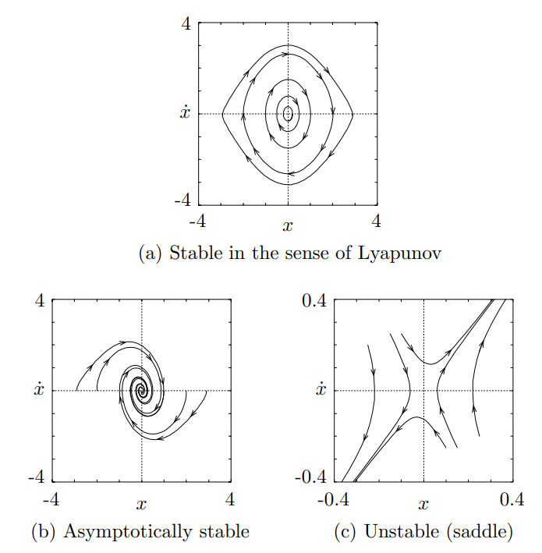
Exponential Stability and Rate of Convergence
- $x^{*}$ is exponentially stable equilibrium point if $∃m,a,ϵ>0$ such that
- $\left|\left|x\left(t\right)\right|\right|≤me^{-a\left(t-t_{0}\right)}\left|\left|x\left(t_{0}\right)\right|\right|…(3)$
- $∀\left|\left|x\left(t_{0}\right)\right|\right|≤ϵ$ and $t≥t_{0}$
- Largest constant $a$ which can be utilised is the rate of convergence
- Exponential stability is considered a strong form of stability
- It implies uniform asymptotic stability
- It can be shown to be robust perturbations
- Global exponential stable is the ideal stability
Direct Method of Lyapunov
- Allows stability determination without explicitly integrating the DE
- It works by considering there to be a ‘measure of energy’ in the system
- The rate of change of the energy is then studied
- Consider $B_{ϵ}$ a ball of size $ϵ$ centred at the origin
- Locally Positive Definite Functions (LPDF)
- Continuous function $V:R^{n}×R_{+}→R$ is a LPDF if
- For some $ϵ>0$ and some continuous strictly increasing function $α:R_{+}→R$
- $V\left(0,t\right)=0$ and $V\left(x,t\right)≥α\left(\left|\left|x\right|\right|\right), ∀x∈B_{ϵ}, ∀t≥0…(4)$
- Is locally an energy function
- Positive Definite Functions (PDF)
- $V$ is positive definite if it is LPDF and $p→∞\underset{⇒}{ }α\left(p\right)→∞$
- Is globally an energy function
- Decrescent Function
- $V$ is decrescent
- $V\left(x,t\right)≤β\left(\left|\left|x\right|\right|\right), ∀x∈B_{ϵ}, ∀t≥0…(5)$
- Bounds the energy function
- To find stability for an appropriate energy function
- When $V\left(x,t\right)$ is a locally positive definite function and $\dot{V}\left(x,t\right)≤0$ then the equilibrium point is stable
- Time derivative of $V$ is taken along the system’s trajectories
- $\dot{V}{\left.​\right|}_{\dot{x}=f(x,t)}=\frac{δV}{δt}+\frac{δV}{δx}f$

Basic Theorem of Lyapunov
- Let $V(x,t)$ be a non-negative function with $\dot{V}$ along trajectories of the system
- If $V$ is LPDF and $\dot{V≤}0$ locally in $x, ∀t$, it is locally stable in the sense of Lyapunov
- If $V$ is LPDF and decrescent and $\dot{V≤}0$ locally in $x, ∀t$, then the origin of the system is locally stable in the sense of Lyapunov
- If $V$ is LPDF and decresent and $-\dot{V}$ is LPDF, then the origin of the system is uniformly locally asymptotically stable
- If $V$ is PDF and decrescent and $-\dot{V}$ is PDF, then the origin of the system is uniformly globally asymptotically stable
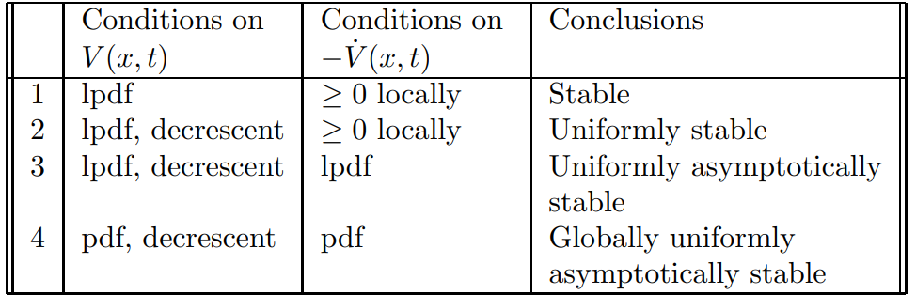
- Converse of basic theorem of Lyapunov is true
- I.e., if it is stable, then $V$ exists
- Difficult to compute Lyapunov function
Exponential Stability Theorem
- $x^{*}=0$is an exponentially stable equilibrium point of $\overset{.}{x}=f(x,t)$ if and only if $∃ϵ>0$ and function $V(x,t)$ such that
- $α_{1}{\left|\left|a\right|\right|}^{2}≤V\left(x,t\right)≤α_{2}{\left|\left|a\right|\right|}^{2}…(6)$
- $\overset{.}{V}{\left.​\right|}_{\overset{.}{x}=f(x,t)}≤-α_{3}{\left|\left|x\right|\right|}^{2}…(7)$
- $\left|\left|\frac{δV}{δx}\left(x,t\right)\right|\right|≤α\left|\left|x\right|\right|…(8)$
- For $α_{1},α_{2},α_{3},α_{4}∈R_{+}$ and $\left|\left|x\right|\right|≤ϵ$
- Rate of convergence for system satisfying theorem is
- $m≤{\left(\frac{α_{2}}{α_{1}}\right)}^{\frac{1}{2}}$
- $α≥\frac{α_{3}}{2α_{2}}$
- These two are bounds in equation 3
- $∴x^{*}=0$ is globally exponentially stable if it holds $∀x$

Indirect Method of Lyapunov
- Uses linearization of a system to determine the local stability
- Consider $\overset{.}{x}=f(x,t)$
- $f\left(0,t\right)=0, ∀t≥0$
- Define the Jacobian matrix of $f\left(x,t\right)$ with respect to $x$at the origin as
- $A\left(t\right)=\frac{δf\left(x,t\right)}{δx}{\left.​\right|}_{x=0}…(9)$
- Therefore, for each fixed $t$, the remainder is
- $f_{1}\left(x,t\right)=f\left(x,t\right)-A\left(t\right)x…(10)$
- $f_{1}(x,t)$ approaches zero as $x$ approaches zero
- Does not necessarily approach zero uniformly
- To approach zero uniformly
- $\lim_{\left|\left|x\right|\right|→0}{\sup_{t≥0}{\frac{\left|\left|f_{1}\left(x,t\right)\right|\right|}{\left|\left|x\right|\right|}}}=0…(11)$
- If this is true, then $\overset{.}{z}=A\left(t\right)z$
- Is referred to as the uniform linearization of $\overset{.}{x}=f(x,t)$
- When the linearization exists, its stability determines the local stability of the original nonlinear equation
Stability by Linearization
- Assume $\lim_{\left|\left|x\right|\right|→0}{\sup_{t≥0}{\frac{\left|\left|f_{1}\left(x,t\right)\right|\right|}{\left|\left|x\right|\right|}}}=0$
- Let $A(∙)$ defined in equation 9 be bounded
- If $0$ is a uniformly asymptotically stable equilibrium point of $\overset{.}{z}=A\left(t\right)z$ then it is a locally uniformly asymptotically stable equilibrium point of $\overset{.}{x}=f(x,t)$
- This theorem requires uniform asymptotic stability of the linearized system to prove uniform asymptotic stability of the nonlinear system
- Global uniform asymptotic stability of linearization Local uniform asymptotic stability on nonlinear

